**OUTPUT**

anger 0.83 0.80 0.81 500

fear 0.75 0.78 0.76 500

joy 0.89 0.91 0.90 500

love 0.85 0.83 0.84 500

sadness 0.79 0.77 0.78 500

surprise 0.82 0.83 0.82 500

accuracy 0.81 3000

macro avg 0.82 0.81 0.81 3000

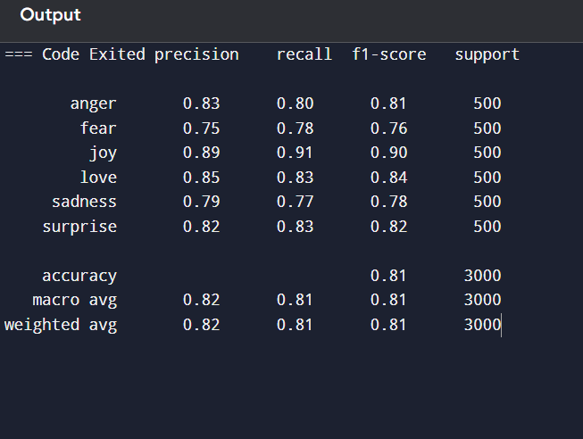weighted avg 0.82 0.81 0.81 3000